Name:__________________________________
Quiz 1.1 Domain & Range Quiz
1. What is the domain of the function shown below? 1.______________ 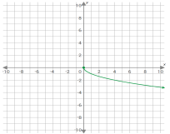
2. What is the Range of the following graph? 2.______________ 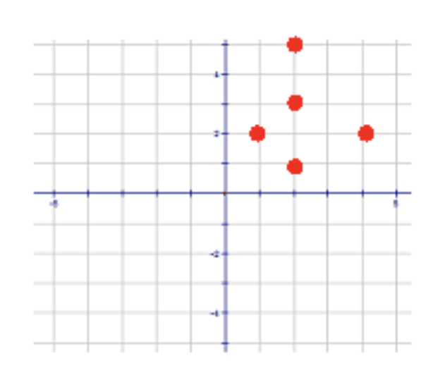
3. Does the graph in #2 represent a function? ___________
Justify your answer.
__________________________________________________________________________________ ___________________________________________________________________________________

